**NAME:BHUVANESHWARI K**

**ROLL NO:230701055**

**SUBJECT NAME:CS23332-FUNDAMENTALS OF DATA SCIENCE**

**DATE:30.07.2024**

import pandas as pd

import numpy as np

import seaborn as sns

import matplotlib.pyplot as plt

%matplotlib inline

data=pd.read_csv('/content/Iris_Dataset.csv') data

**Id SepalLengthCm SepalWidthCm PetalLengthCm PetalWidthCm variety**

1. 1 5.1 3.5 1.4 0.2 Iris-setosa
2. 2 4.9 3.0 1.4 0.2 Iris-setosa
3. 3 4.7 3.2 1.3 0.2 Iris-setosa
4. 4 4.6 3.1 1.5 0.2 Iris-setosa
5. 5 5.0 3.6 1.4 0.2 Iris-setosa

**...** ... ... ... ... ... ...

1. 146 6.7 3.0 5.2 2.3 Iris-virginica
2. 147 6.3 2.5 5.0 1.9 Iris-virginica
3. 148 6.5 3.0 5.2 2.0 Iris-virginica
4. 149 6.2 3.4 5.4 2.3 Iris-virginica
5. 150 5.9 3.0 5.1 1.8 Iris-virginica
6. rows × 6 columns

data.info()

<class 'pandas.core.frame.DataFrame'> RangeIndex: 150 entries, 0 to 149

Data columns (total 6 columns):

# Column Non-Null Count Dtype

--- ------ -------------- -----

1. Id 150 non-null int64
2. SepalLengthCm 150 non-null float64
3. SepalWidthCm 150 non-null float64
4. PetalLengthCm 150 non-null float64
5. PetalWidthCm 150 non-null float64
6. variety 150 non-null object dtypes: float64(4), int64(1), object(1) memory usage: 7.2+ KB

data.describe()

**Id SepalLengthCm SepalWidthCm PetalLengthCm PetalWidthCm**

**count** 150.000000 150.000000 150.000000 150.000000 150.000000 **mean** 75.500000 5.843333 3.054000 3.758667 1.198667 **std** 43.445368 0.828066 0.433594 1.764420 0.763161 **min** 1.000000 4.300000 2.000000 1.000000 0.100000

**25%** 38.250000 5.100000 2.800000 1.600000 0.300000

**50%** 75.500000 5.800000 3.000000 4.350000 1.300000 **75%** 112.750000 6.400000 3.300000 5.100000 1.800000 **max** 150 000000 7 900000 4 400000 6 900000 2 500000

data.value_counts('variety')

**count**

**variety**

**Iris-setosa** 50

**Iris-versicolor** 50

**Iris-virginica** 50

https://colab.research.google.com/drive/1Tqx5IOXjHro7-CLF16NYNKyRMTEo1INN#printMode=true 1/5 10/14/24, 12:23 PM irispetalsepal.ipynb - Colab

sns.countplot(x='variety',data=data,) plt.show()

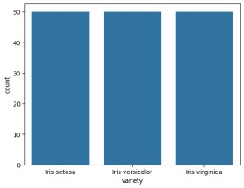

dummies=pd.get_dummies(data.variety)

FinalDataset=pd.concat([pd.get_dummies(data.variety),data.iloc[:,[0,1,2,3]]],axis=1)

FinalDataset.head()

**Iris-setosa Iris-versicolor Iris-virginica Id SepalLengthCm SepalWidthCm PetalLengthCm 0** True

False False 1 5.1 3.5 1.4 **1** True False False 2 4.9 3.0 1.4 **2** True False False 3 4.7 3.2 1.3 **3** True False False 4 4.6

3.1 1.5 **4** True False False 5 5 0 3 6 1 4

sns.scatterplot(x='SepalLengthCm',y='SepalWidthCm',hue='variety',data=data,)

<Axes: xlabel='SepalLengthCm', ylabel='SepalWidthCm'>

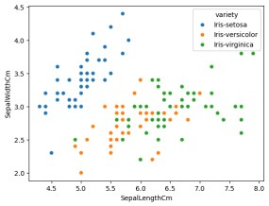

sns.scatterplot(x='PetalLengthCm',y='PetalWidthCm',hue='variety',data=data,)

https://colab.research.google.com/drive/1Tqx5IOXjHro7-CLF16NYNKyRMTEo1INN#printMode=true 2/5

10/14/24, 12:23 PM irispetalsepal.ipynb - Colab

<Axes: xlabel='PetalLengthCm', ylabel='PetalWidthCm'>

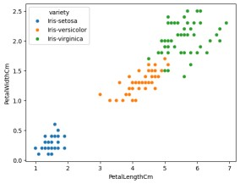

sns.pairplot(data,hue='variety',height=3);

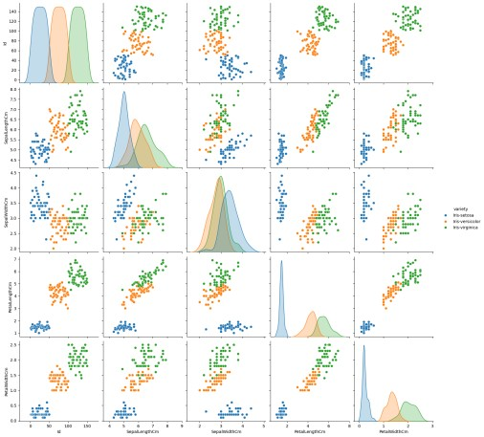

https://colab.research.google.com/drive/1Tqx5IOXjHro7-CLF16NYNKyRMTEo1INN#printMode=true 3/5

10/14/24, 12:23 PM irispetalsepal.ipynb - Colab plt.show()

sns.FacetGrid(data,hue='variety',height=5).map(sns.histplot,'PetalLengthCm').add_legend(); plt.show();

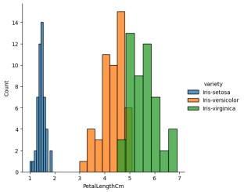

sns.FacetGrid(data,hue='variety',height=5).map(sns.histplot,'PetalWidthCm').add_legend(); plt.show();

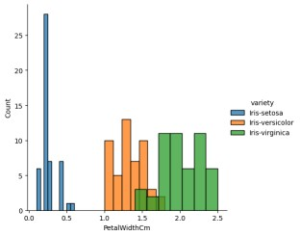

sns.FacetGrid(data,hue='variety',height=5).map(sns.histplot,'SepalLengthCm').add_legend(); plt.show();

https://colab.research.google.com/drive/1Tqx5IOXjHro7-CLF16NYNKyRMTEo1INN#printMode=true 4/5 10/14/24, 12:23 PM irispetalsepal.ipynb - Colab

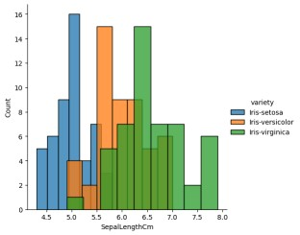

sns.FacetGrid(data,hue='variety',height=5).map(sns.histplot,'SepalWidthCm').add_legend(); plt.show();

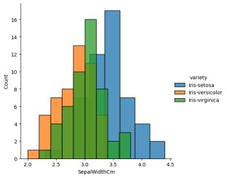

https://colab.research.google.com/drive/1Tqx5IOXjHro7-CLF16NYNKyRMTEo1INN#printMode=true 5/5

**NAME: BHUVANESHWARI K**

**ROLL NO:230701055**

**SUBJECT NAME:CS23332-FUNDAMENTALS OF DATA SCIENCE**

**DATE:06.08.2024**

import numpy as np array=np.random.randint(1,100,9) array array([83, 25, 19, 47, 62, 15, 96, 39, 51])

np.sqrt(array)

array([9.11043358, 5. , 4.35889894, 6.8556546 , 7.87400787, 3.87298335, 9.79795897, 6.244998 , 7.14142843])

array.ndim

1

new_array=array.reshape(3,3)

new_array

array([[83, 25, 19],

[47, 62, 15],

[96, 39, 51]])

new_array.ndim

2

new_array.ravel() array([83, 25, 19, 47, 62, 15, 96, 39, 51])

newm=new_array.reshape(3,3)

newm

array([[83, 25, 19],

[47, 62, 15],

[96, 39, 51]])

newm[2,1:3] array([39, 51])

newm[1:2,1:3] array([[62, 15]])

new_array[0:3,0:0] array([], shape=(3, 0), dtype=int64)

new_array[0:2,0:1]

array([[83], [47]])

new_array[0:3,0:1]

array([[83],

[47],

[96]])

new_array[1:3]

array([[47, 62, 15],

[96, 39, 51]])

https://colab.research.google.com/drive/13G4FlnBMXbErA0zk2vKl_o82OxhSkVnk#scrollTo=-SNYqjk34QWE&printMode=true 1/2 10/14/24, 12:45 PM Untitled17.ipynb - Colab

https://colab.research.google.com/drive/13G4FlnBMXbErA0zk2vKl_o82OxhSkVnk#scrollTo=-SNYqjk34QWE&printMode=true 2/2

**NAME: BHUVANESHWARI K**

**ROLL NO:230701055**

**SUBJECT NAME:CS23332-FUNDAMENTALS OF DATA SCIENCE**

**DATE:13.08.2024**

import numpy as np import pandas as pd list=[[1,'Smith',50000],[2,'Jones',60000]]

df=pd.DataFrame(list) df

**0 1 2**

1. 1 Smith 50000
2. 2 Jones 60000

df.columns=['Empd','Name','Salary'] df

**Empd Name Salary**

1. 1 Smith 50000
2. 2 Jones 60000

df.info()

<class 'pandas.core.frame.DataFrame'>

RangeIndex: 2 entries, 0 to 1 Data columns (total 3 columns):

# Column Non-Null Count Dtype

--- ------ -------------- -----

1. Empd 2 non-null int64
2. Name 2 non-null object
3. Salary 2 non-null int64 dtypes: int64(2), object(1) memory usage: 176.0+ bytes

df=pd.read_csv("/content/50_Startups.csv")

df.info()

<class 'pandas.core.frame.DataFrame'>

RangeIndex: 50 entries, 0 to 49 Data columns (total 5 columns):

# Column Non-Null Count Dtype

--- ------ -------------- ----0 R&D Spend 50 non-null float64

1. Administration 50 non-null float64
2. Marketing Spend 50 non-null float64
3. State 50 non-null object
4. Profit 50 non-null float64 dtypes: float64(4), object(1) memory usage: 2.1+ KB

df.head()

**R&D Spend Administration Marketing Spend State Profit**

1. 165349.20 136897.80 471784.10 New York 192261.83
2. 162597.70 151377.59 443898.53 California 191792.06
3. 153441.51 101145.55 407934.54 Florida 191050.39
4. 144372.41 118671.85 383199.62 New York 182901.99
5. 142107 34 91391 77 366168 42 Florida 166187 94

df.tail()

**R&D Spend Administration Marketing Spend State Profit**

1. 1000.23 124153.04 1903.93 New York 64926.08
2. 1315.46 115816.21 297114.46 Florida 49490.75
3. 0.00 135426.92 0.00 California 42559.73
4. 542.05 51743.15 0.00 New York 35673.41
5. 0 00 116983 80 45173 06 California 14681 40

https://colab.research.google.com/drive/1TNEzkVEMxSI_3eUDFZrcEeJH-g7BNg2j#scrollTo=lDn_tbKJiBVI&printMode=true 1/4 10/14/24, 12:15 PM pandasclass.ipynb - Colab

import numpy as np import pandas as pd

df=pd.read_csv("/content/employee.csv")

df.head() **emp id name salary**

1. 1 SREE VARSSINI K S 5000
2. 2 SREEMATHI B 6000
3. 3 SREYA G 7000
4. 4 SREYASKARI MULLAPUDI 5000
5. 5 SRI AKASH U G 8000

df.tail() **emp id name salary**

1. 3 SREYA G 7000
2. 4 SREYASKARI MULLAPUDI 5000
3. 5 SRI AKASH U G 8000
4. 6 SRI HARSHAVARDHANAN R 3000
5. 7 SRI HARSHAVARDHANAN R 6000

df.info()

<class 'pandas.core.frame.DataFrame'>

RangeIndex: 7 entries, 0 to 6 Data columns (total 3 columns):

# Column Non-Null Count Dtype

--- ------ -------------- ----0 emp id 7 non-null int64

1. name 7 non-null object
2. salary 7 non-null int64 dtypes: int64(2), object(1) memory usage: 296.0+ bytes

df.salary

**salary**

1. 5000
2. 6000
3. 7000
4. 5000
5. 8000
6. 3000
7. 6000

type(df.salary)

**pandas.core.series.Series**

def __init__(data=None, index=None, dtype: Dtype | None=None, name=None, copy: bool | None=None, fastpath: bool=False) -> None

One-dimensional ndarray with axis labels (including time series).

Labels need not be unique but must be a hashable type. The object supports both integer- and label-based indexing and provides a host of

methods for performing operations involving the index. Statistical th d f d h b idd t t ti ll l d

df.salary.mean()

5714.285714285715

https://colab.research.google.com/drive/1TNEzkVEMxSI_3eUDFZrcEeJH-g7BNg2j#scrollTo=lDn_tbKJiBVI&printMode=true 2/4

10/14/24, 12:15 PM pandasclass.ipynb - Colab df.salary.median()

6000.0

df.salary.mode()

**salary**

1. 5000
2. 6000

df.salary.var()

2571428.5714285714

df.salary.std()

1603.5674514745463

df.describe()

**emp id salary**

**count** 7.000000 7.000000 **mean** 4.000000 5714.285714 **std** 2.160247 1603.567451 **min** 1.000000 3000.000000

**25%** 2.500000 5000.000000

**50%** 4.000000 6000.000000 **75%** 5.500000 6500.000000 **max** 7 000000 8000 000000

df.describe(include='all')

**emp id name salary**

**count** 7.000000 7 7.000000 **unique** NaN 6 NaN **top** NaN SRI HARSHAVARDHANAN R NaN **freq** NaN 2 NaN **mean** 4.000000 NaN 5714.285714 **std** 2.160247 NaN 1603.567451 **min** 1.000000 NaN 3000.000000

**25%** 2.500000 NaN 5000.000000

**50%** 4.000000 NaN 6000.000000 **75%** 5.500000 NaN 6500.000000 **max** 7 000000 NaN 8000 000000

empCol=df.columns

empCol

Index(['emp id', 'name ', 'salary'], dtype='object')

emparray=df.values

emparray

array([[1, 'SREE VARSSINI K S', 5000],

[2, 'SREEMATHI B', 6000],

[3, 'SREYA G', 7000],

[4, 'SREYASKARI MULLAPUDI', 5000],

[5, 'SRI AKASH U G', 8000],

[6, 'SRI HARSHAVARDHANAN R', 3000],

[7, 'SRI HARSHAVARDHANAN R', 6000]], dtype=object)

employee_DF=pd.DataFrame(emparray,columns=empCol)

employee_DF

**emp id name salary**

1. 1 SREE VARSSINI K S 5000
2. 2 SREEMATHI B 6000
3. 3 SREYA G 7000
4. 4 SREYASKARI MULLAPUDI 5000
5. 5 SRI AKASH U G 8000
6. 6 SRI HARSHAVARDHANAN R 3000
7. 7 SRI HARSHAVARDHANAN R 6000

Start coding or generate with AI.

**NAME: BHUVANESHWARI K**

**ROLL NO:230701262**

**SUBJECT NAME:CS23332-FUNDAMENTALS OF DATA SCIENCE**

**DATE:20.08.2024**

#sample calculation for low range(lr) , upper range (ur),percentile import numpy as np

array=np.random.randint(1,100,16) # randomly generate 16 numbers between 1 to 100 array

array([27, 50, 44, 6, 58, 61, 23, 86, 67, 20, 75, 7, 79, 61, 90, 54])

array.mean()

50.5

np.percentile(array,25)

26.0

np.percentile(array,50)

56.0

np.percentile(array,75)

69.0

np.percentile(array,100)

90.0

#outliers detection def outDetection(array):

sorted(array)

Q1,Q3=np.percentile(array,[25,75]) IQR=Q3-Q1 lr=Q1-(1.5*IQR) ur=Q3+(1.5*IQR) return lr,ur

lr,ur=outDetection(array)

lr,ur

(-38.5, 133.5)

import seaborn as sns %matplotlib inline sns.displot(array)

<seaborn.axisgrid.FacetGrid at 0x78f3291c2710>

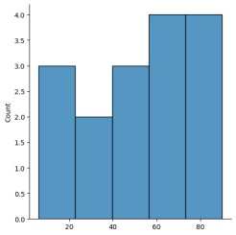

sns.distplot(array)

https://colab.research.google.com/drive/1kQyWP9o5X06QKGZ2THDQgeBxvO2w6OZE#scrollTo=hlPKHYm8_fEK&printMode=true 1/3 10/14/24, 1:18 PM Untitled17.ipynb - Colab

<ipython-input-19-d72101983c40>:1: UserWarning:

`distplot` is a deprecated function and will be removed in seaborn v0.14.0.

Please adapt your code to use either `displot` (a figure-level function with similar flexibility) or `histplot` (an axes-level function for histograms).

For a guide to updating your code to use the new functions, please see https://gist.github.com/mwaskom/de44147ed2974457ad6372750bbe5751

sns.distplot(array)

<Axes: ylabel='Density'>

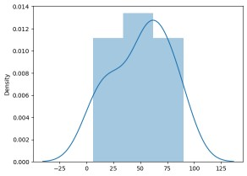

new_array=array[(array>lr) & (array<ur)] new_array

array([27, 50, 44, 6, 58, 61, 23, 86, 67, 20, 75, 7, 79, 61, 90, 54])

sns.displot(new_array)

<seaborn.axisgrid.FacetGrid at 0x78f2e09bb580>



lr1,ur1=outDetection(new_array) lr1,ur1

(-38.5, 133.5)

final_array=new_array[(new_array>lr1) & (new_array<ur1)] final_array

array([27, 50, 44, 6, 58, 61, 23, 86, 67, 20, 75, 7, 79, 61, 90, 54])

sns.distplot(final_array)

<ipython-input-18-7ba96ada5b76>:1: UserWarning:

`distplot` is a deprecated function and will be removed in seaborn v0.14.0.

Please adapt your code to use either `displot` (a figure-level function with similar flexibility) or `histplot` (an axes-level function for histograms).

For a guide to updating your code to use the new functions, please see https://gist.github.com/mwaskom/de44147ed2974457ad6372750bbe5751

sns.distplot(final_array) <Axes: ylabel='Density'>



**NAME: BHUVANESHWARI k**

**ROLL NO:230701055**

**SUBJECT NAME:CS23332-FUNDAMENTALS OF DATA SCIENCE**

**DATE:27.08.2024**

**Handling Missing and Inappropriate Data in a Dataset**

Aim: Demonstrate an experiment to handle missing data and inappropriate data in a Data set using Python Pandas Library for Data Preprocessing.

Dataset Given:

**Hotel.csv**

|  |  |  |  |  |  |  |  |  |
| --- | --- | --- | --- | --- | --- | --- | --- | --- |
| **CustomerID** | **Age_Group** | **Rating(1-5)** | **Hotel** | **FoodPreference** | **Bill** | **NoOfPax** | **EstimatedSalary** | **Age_Group** |
| 1 | 20-25 | 4 | Ibis | veg | 1300 | 2 | 40000 | 20-25 |
| 2 | 30-35 | 5 | LemonTree | Non-Veg | 2000 | 3 | 59000 | 30-35 |
| 3 | 25-30 | 6 | RedFox | Veg | 1322 | 2 | 30000 | 25-30 |
| 4 | 20-25 | -1 | LemonTree | Veg | 1234 | 2 | 120000 | 20-25 |
| 5 | 35+ | 3 | Ibis | Vegetarian | 989 | 2 | 45000 | 35+ |
| 6 | 35+ | 3 | Ibys | Non-Veg | 1909 | 2 | 122220 | 35+ |
| 7 | 35+ | 4 | RedFox | Vegetarian | 1000 | -1 | 21122 | 35+ |
| 8 | 20-25 | 7 | LemonTree | Veg | 2999 | -10 | 345673 | 20-25 |
| 9 | 25-30 | 2 | Ibis | Non-Veg | 3456 | 3 | -99999 | 25-30 |
| 9 | 25-30 | 2 | Ibis | Non-Veg | 3456 | 3 | -99999 | 25-30 |
| 10 | 30-35 | 5 | RedFox | non-Veg | -  6755 | 4 | 87777 | 30-35 |

**About Dataset:**

No.of Columns =9 (called as series – CustomerID, Age_Group, Rating(1-5),Hotel, FoodPreference, Bill, NoOfPax, EstimatedSalary)

CutomerID: Numerical Continuous data

Age: Categorical Data

Rating (1-5): Numerical Discrete Data

Hotel: Categorical Data

Food: Categorical Data Bill: Numerical Continuous data NoOfPax: Numerical Discrete

EstimatedSalary: Numerical Continuous data

**Python Code:**

# Upload Hotel.csv and convert it into dataFrame **import numpy as np import pandas as pd df=pd.read_csv("Hotel_Dataset.csv") df**

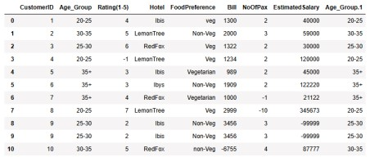

#From the dataframe identify the duplicate row(i.e row 9)

# The duplicated() method returns a Series with True and False values that describe which rows in the DataFrame are duplicated and not. **df.duplicated()**

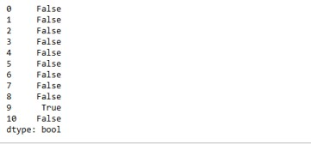

# The info() method prints information about the DataFrame. The information contains the number of columns, column labels, column data types, memory usage, range index, and the number of cells in each column (non-null values).

**df.info()**

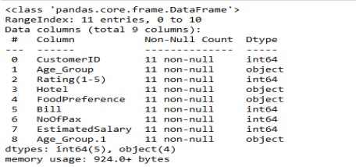

# The drop_duplicates() method removes duplicate rows. **df.drop_duplicates(inplace=True) df**

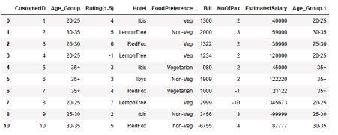

#While removing duplicate record row index also removed

# The len() function to return the length of an object. With a dataframe, the function returns the number of rows.

**len(df)**

10

#Reset the index **index=np.array(list(range(0,len(df)))) df.set_index(index,inplace=True) index**

array([0, 1, 2, 3, 4, 5, 6, 7, 8, 9])

**df**

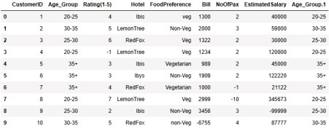

# Axis refers to the dimensions of a DataFrame (index and columns) or Series (index only) Use axis=0 to apply functions row-wise along the index. Use axis=1 to apply functions column-wise across columns.

**df.drop(['Age_Group.1'],axis=1,inplace=True) df**

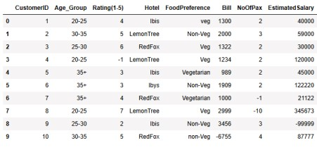

# The function . loc is typically used for label indexing and can access multiple columns. **df.CustomerID.loc[df.CustomerID<0]=np.nan**

**df.Bill.loc[df.Bill<0]=np.nan df.EstimatedSalary.loc[df.EstimatedSalary<0]=np.nan**

**df**

C:\Users\Ayyadurai\AppData\Local\Temp\ipykernel_5300\2580639570.py:1: S ettingWithCopyWarning:

A value is trying to be set on a copy of a slice from a DataFrame See the caveats in the documentation: https://pandas.pydata.org/pandas docs/stable/user_guide/indexing.html#returning-a-view-versus-a-copy df.CustomerID.loc[df.CustomerID<0]=np.nan

df.Bill.loc[df.Bill<0]=np.nan

C:\Users\Ayyadurai\AppData\Local\Temp\ipykernel_5300\2580639570.py:2: S ettingWithCopyWarning:

A value is trying to be set on a copy of a slice from a DataFrame df.EstimatedSalary.loc[df.EstimatedSalary<0]=np.nan

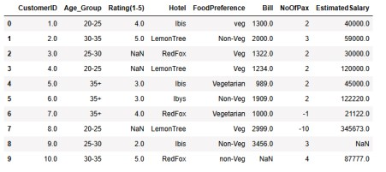

**df['NoOfPax'].loc[(df['NoOfPax']<1) | (df['NoOfPax']>20)]=np.nan df**

C:\Users\Ayyadurai\AppData\Local\Temp\ipykernel_5300\2129877948.py:1: S

ettingWithCopyWarning:

A value is trying to be set on a copy of a slice from a DataFrame

See the caveats in the documentation: https://pandas.pydata.org/pandas docs/stable/user_guide/indexing.html#returning-a-view-versus-a-copy df['NoOfPax'].loc[(df['NoOfPax']<1) | (df['NoOfPax']>20)]=np.nan

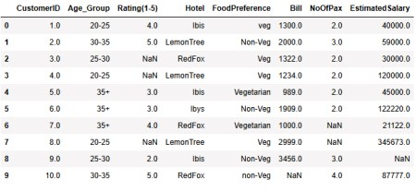

**df.Age_Group.unique()**

array(['20-25', '30-35', '25-30', '35+'], dtype=object)

**df.Hotel.unique()**

array(['Ibis', 'LemonTree', 'RedFox', 'Ibys'], dtype=object)

# Using the inplace=True keyword in a pandas method changes the default behaviour such that the operation on the dataframe doesn't return anything, it instead 'modifies the underlying data **df.Hotel.replace(['Ibys'],'Ibis',inplace=True) df.FoodPreference.unique**

<bound method Series.unique of 0 veg

1. Non-Veg
2. Veg
3. Veg
4. Vegetarian
5. Non-Veg
6. Vegetarian
7. Veg
8. Non-Veg
9. non-Veg

Name: FoodPreference, dtype: object>

**df.FoodPreference.replace(['Vegetarian','veg'],'Veg',inplace=True) df.FoodPreference.replace(['non-Veg'],'Non-Veg',inplace=True)**

# Fillna is a Pandas function to fill the NA/NaN values with the specified method.

# If column or feature is numerical continuous data then replace the missing(NaN) value by taking mean value.

# If column or feature is numerical discrete data then replace the missing(NaN) value by taking median value.

# If column or feature is non-numerical i.e Categorical data then replace the missing(NaN) value by taking mode value.

**df.EstimatedSalary.fillna(round(df.EstimatedSalary.mean()),inplace=True) df.NoOfPax.fillna(round(df.NoOfPax.median()),inplace=True) df['Rating(1-5)'].fillna(round(df['Rating(1-5)'].median()), inplace=True) df.Bill.fillna(round(df.Bill.mean()),inplace=True) df**

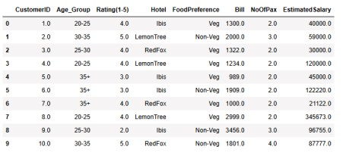

**NAME: BHUVANESHWARI K**

**ROLL NO:230701055**

**SUBJECT NAME:CS23332-FUNDAMENTALS OF DATA SCIENCE**

**DATE:03.09.2024**

import numpy as np

import pandas as pd df=pd.read_csv('/content/pre-process_datasample.csv') df

**Country Age Salary Purchased**

1. France 44.0 72000.0 No
2. Spain 27.0 48000.0 Yes
3. Germany 30.0 54000.0 No
4. Spain 38.0 61000.0 No
5. Germany 40.0 NaN Yes
6. France 35.0 58000.0 Yes
7. Spain NaN 52000.0 No
8. France 48.0 79000.0 Yes
9. NaN 50.0 83000.0 No
10. France 37.0 67000.0 Yes

Generate code with df View recommended plots

Next steps: df.head() New interactive sheet

**Country Age Salary Purchased 0** France 44.0 72000.0 No **1** Spain 27.0

48000.0 Yes **2** Germany 30.0 54000.0 No **3**

Spain 38.0 61000.0 No **4** Germany 40 0

NaN Yes

New interactive sheet

Next steps:

Generate code with df View recommended plots

df.Country.fillna(df.Country.mode()[0],inplace=True)

features=df.iloc[:,:-1].values

<ipython-input-5-20665a0bbaa1>:1: FutureWarning: A value is trying to be set on a copy of a DataFrame o

The behavior will change in pandas 3.0. This inplace method will never work because the intermediate ob

For example, when doing 'df[col].method(value, inplace=True)', try using 'df.method({col: value}, inpla

df.Country.fillna(df.Country.mode()[0],inplace=True)

label=df.iloc[:,-1].values

Start coding or generate with AI.

https://colab.research.google.com/drive/1Qdb3r_JJTzcANnUYmofxmJd30xZGEnKg#scrollTo=KdrqXPjiF0Pn&printMode=true 1/4 10/5/24, 8:09 PM 09.09.2024-sklearn.ipynb - Colab

from sklearn.impute import SimpleImputer

age=SimpleImputer(strategy="mean",missing_values=np.nan) Salary=SimpleImputer(strategy="mean",missing_values=np.nan)

age.fit(features[:,[1]])

▾ SimpleImputer i?

SimpleImputer()

Salary.fit(features[:,[2]])

▾ SimpleImputer i?

SimpleImputer()

SimpleImputer()

▾ SimpleImputer i?

SimpleImputer()

features[:,[1]]=age.transform(features[:,[1]])

features[:,[2]]=Salary.transform(features[:,[2]])

features

array([['France', 44.0, 72000.0],

['Spain', 27.0, 48000.0],

['Germany', 30.0, 54000.0],

['Spain', 38.0, 61000.0],

['Germany', 40.0, 63777.77777777778],

['France', 35.0, 58000.0],

['Spain', 38.77777777777778, 52000.0],

['France', 48.0, 79000.0],

['France', 50.0, 83000.0],

['France', 37.0, 67000.0]], dtype=object)

from sklearn.preprocessing import OneHotEncoder

oh = OneHotEncoder(sparse_output=False)

Country=oh.fit_transform(features[:,[0]])

Country

array([[1., 0., 0.],

[0., 0., 1.],

[0., 1., 0.],

[0., 0., 1.],

[0., 1., 0.],

[1., 0., 0.],

[0., 0., 1.],

[1., 0., 0.],

https://colab.research.google.com/drive/1Qdb3r_JJTzcANnUYmofxmJd30xZGEnKg#scrollTo=KdrqXPjiF0Pn&printMode=true 2/4 10/5/24, 8:09 PM 09.09.2024-sklearn.ipynb - Colab

[1., 0., 0.],

[1., 0., 0.]])

final_set=np.concatenate((Country,features[:,[1,2]]),axis=1)

final_set

array([[1.0, 0.0, 0.0, 44.0, 72000.0],

[0.0, 0.0, 1.0, 27.0, 48000.0],

[0.0, 1.0, 0.0, 30.0, 54000.0],

[0.0, 0.0, 1.0, 38.0, 61000.0],

[0.0, 1.0, 0.0, 40.0, 63777.77777777778],

[1.0, 0.0, 0.0, 35.0, 58000.0],

[0.0, 0.0, 1.0, 38.77777777777778, 52000.0],

[1.0, 0.0, 0.0, 48.0, 79000.0],

[1.0, 0.0, 0.0, 50.0, 83000.0],

[1.0, 0.0, 0.0, 37.0, 67000.0]], dtype=object)

from sklearn.preprocessing import StandardScaler

sc=StandardScaler() sc.fit(final_set)

feat_standard_scaler=sc.transform(final_set)

feat_standard_scaler

array([[ 1.00000000e+00, -5.00000000e-01, -6.54653671e-01,

7.58874362e-01, 7.49473254e-01],

[-1.00000000e+00, -5.00000000e-01, 1.52752523e+00,

-1.71150388e+00, -1.43817841e+00],

[-1.00000000e+00, 2.00000000e+00, -6.54653671e-01,

-1.27555478e+00, -8.91265492e-01],

[-1.00000000e+00, -5.00000000e-01, 1.52752523e+00,

-1.13023841e-01, -2.53200424e-01],

[-1.00000000e+00, 2.00000000e+00, -6.54653671e-01,

1.77608893e-01, 6.63219199e-16],

[ 1.00000000e+00, -5.00000000e-01, -6.54653671e-01,

-5.48972942e-01, -5.26656882e-01],

[-1.00000000e+00, -5.00000000e-01, 1.52752523e+00,

0.00000000e+00, -1.07356980e+00],

[ 1.00000000e+00, -5.00000000e-01, -6.54653671e-01,

1.34013983e+00, 1.38753832e+00],

[ 1.00000000e+00, -5.00000000e-01, -6.54653671e-01,

1.63077256e+00, 1.75214693e+00],

[ 1.00000000e+00, -5.00000000e-01, -6.54653671e-01, -2.58340208e-01, 2.93712492e-01]])

from sklearn.preprocessing import MinMaxScaler

mms=MinMaxScaler(feature_range=(0,1)) mms.fit(final_set)

feat_minmax_scaler=mms.transform(final_set) feat_minmax_scaler

array([[1. , 0. , 0. , 0.73913043, 0.68571429],

[0. , 0. , 1. , 0. , 0. ],

[0. , 1. , 0. , 0.13043478, 0.17142857],

[0. , 0. , 1. , 0.47826087, 0.37142857],

1. , 1. , 0. , 0.56521739, 0.45079365],
2. , 0. , 0. , 0.34782609, 0.28571429],
3. , 0. , 1. , 0.51207729, 0.11428571],
4. , 0. , 0. , 0.91304348, 0.88571429],

[1. , 0. , 0. , 1. , 1. ],

[1. , 0. , 0. , 0.43478261, 0.54285714]])

Start coding or generate with AI.

https://colab.research.google.com/drive/1Qdb3r_JJTzcANnUYmofxmJd30xZGEnKg#scrollTo=KdrqXPjiF0Pn&printMode=true 3/4 10/5/24, 8:09 PM 09.09.2024-sklearn.ipynb - Colab

**NAME: BHUVANESHWARI K**

**ROLL NO:230701055**

**SUBJECT NAME:CS23332-FUNDAMENTALS OF DATA SCIENCE**

**DATE:10.09.2024**

import numpy as np

import pandas as pd

df=pd.read_csv("/content/pre-process_datasample.csv") df

**Country Age Salary Purchased**

1. France 44.0 72000.0 No
2. Spain 27.0 48000.0 Yes
3. Germany 30.0 54000.0 No
4. Spain 38.0 61000.0 No
5. Germany 40.0 NaN Yes
6. France 35.0 58000.0 Yes
7. Spain NaN 52000.0 No
8. France 48.0 79000.0 Yes
9. NaN 50.0 83000.0 No **9** France 37.0 67000.0 Yes

Double-click (or enter) to edit

df.info()

<class 'pandas.core.frame.DataFrame'>

RangeIndex: 10 entries, 0 to 9 Data columns (total 4 columns):

# Column Non-Null Count Dtype

--- ------ -------------- ----0 Country 9 non-null object

1. Age 9 non-null float64
2. Salary 9 non-null float64
3. Purchased 10 non-null object dtypes: float64(2), object(2) memory usage: 448.0+ bytes

df.Country.mode()

**Country**

**0** France

df.Country.mode()[0]

type(df.Country.mode())

**pandas.core.series.Series**

def __init__(data=None, index=None, dtype: Dtype | None=None, name=None, copy: bool | None=None, fastpath: bool=False) -> None

~~index is not None, the resulting Series is reindexed with the index values.~~ dtype : str, numpy.dtype, or ExtensionDtype, optional Data type for the output Series. If not specified, this will be inferred from `data`.

See the :ref:`user guide <basics.dtypes>` for more usages.

name : Hashable, default None

The name to give to the Series

df.Country.fillna(df.Country.mode()[0],inplace=True)

df.Age.fillna(df.Age.median(),inplace=True)

df.Salary.fillna(round(df.Salary.mean()),inplace=True)

df

https://colab.research.google.com/drive/1EflGC8IXnHLCKH8kXH1QwiDhUp6tMHjW#printMode=true 1/3 10/5/24, 6:12 PM 10th Day DataPreprocessing.ipynb - Colab

**Country Age Salary Purchased**

1. France 44.0 72000.0 No
2. Spain 27.0 48000.0 Yes
3. Germany 30.0 54000.0 No
4. Spain 38.0 61000.0 No
5. Germany 40.0 63778.0 Yes
6. France 35.0 58000.0 Yes
7. Spain 38.0 52000.0 No
8. France 48.0 79000.0 Yes
9. France 50.0 83000.0 No
10. France 37 0 67000 0 Yes

pd.get_dummies(df.Country)

**France Germany Spain**

1. True False False
2. False False True
3. False True False
4. False False True
5. False True False
6. True False False
7. False False True
8. True False False
9. True False False
10. True False False

updated_dataset=pd.concat([pd.get_dummies(df.Country),df.iloc[:,[1,2,3]]],axis=1)

updated_dataset

**France Germany Spain Age Salary Purchased**

1. True False False 44.0 72000.0 No
2. False False True 27.0 48000.0 Yes
3. False True False 30.0 54000.0 No
4. False False True 38.0 61000.0 No
5. False True False 40.0 63778.0 Yes
6. True False False 35.0 58000.0 Yes
7. False False True 38.0 52000.0 No
8. True False False 48.0 79000.0 Yes
9. True False False 50.0 83000.0 No
10. True False False 37 0 67000 0 Yes

df.info()

<class 'pandas.core.frame.DataFrame'>

RangeIndex: 10 entries, 0 to 9 Data columns (total 4 columns):

# Column Non-Null Count Dtype

--- ------ -------------- -----

1. Country 10 non-null object
2. Age 10 non-null float64
3. Salary 10 non-null float64
4. Purchased 10 non-null object dtypes: float64(2), object(2) memory usage: 448.0+ bytes

updated_dataset.Purchased.replace(['No','Yes'],[0,1],inplace=True)

updated_dataset

**France Germany Spain Age Salary Purchased**

1. True False False 44.0 72000.0 0
2. False False True 27.0 48000.0 1
3. False True False 30.0 54000.0 0
4. False False True 38.0 61000.0 0
5. False True False 40.0 63778.0 1
6. True False False 35.0 58000.0 1
7. False False True 38.0 52000.0 0
8. True False False 48.0 79000.0 1
9. True False False 50.0 83000.0 0
10. True False False 37 0 67000 0 1

Start coding or

**NAME:BHUVANESHWARI K**

**ROLL NO:230701055**

**SUBJECT NAME:CS23332-FUNDAMENTALS OF DATA SCIENCE**

**DATE:08.10.2024**

import seaborn as sns

import pandas as pd import numpy as np import matplotlib.pyplot as plt %matplotlib inline

tips=sns.load_dataset('tips')

tips.head() **total_bill tip sex smoker day time size**

1. 16.99 1.01 Female No Sun Dinner 2
2. 10.34 1.66 Male No Sun Dinner 3
3. 21.01 3.50 Male No Sun Dinner 3
4. 23.68 3.31 Male No Sun Dinner 2
5. 24.59 3.61 Female No Sun Dinner 4

~~Code Text~~

sns.displot(tips.total_bill,kde=True)

<seaborn.axisgrid.FacetGrid at 0x79bb4c7ea680>

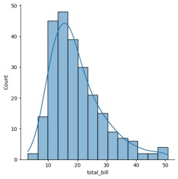

sns.displot(tips.total_bill,kde=False)

https://colab.research.google.com/drive/1ixdO2LyjKtMYUgtZcoc8jSInDGmeKn4_#scrollTo=J9uBGy0XX3rZ&printMode=true 1/9 10/1/24, 9:52 AM 9.9.2024-Visualization.ipynb - Colab

<seaborn.axisgrid.FacetGrid at 0x79bb0b0af580>

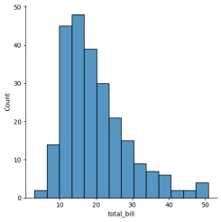

sns.jointplot(x=tips.tip,y=tips.total_bill)

<seaborn.axisgrid.JointGrid at 0x79bb08fc96c0>

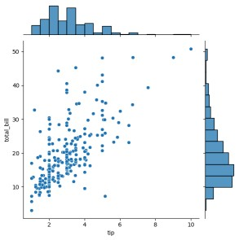

sns.jointplot(x=tips.tip,y=tips.total_bill,kind="reg")

https://colab.research.google.com/drive/1ixdO2LyjKtMYUgtZcoc8jSInDGmeKn4_#scrollTo=J9uBGy0XX3rZ&printMode=true 2/9 10/1/24, 9:52 AM 9.9.2024-Visualization.ipynb - Colab

<seaborn.axisgrid.JointGrid at 0x79bb08fc9cf0>

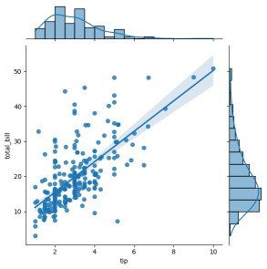

sns.jointplot(x=tips.tip,y=tips.total_bill,kind="hex")

<seaborn.axisgrid.JointGrid at 0x79bb088f4730>

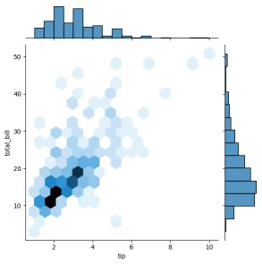

sns.pairplot(tips)

https://colab.research.google.com/drive/1ixdO2LyjKtMYUgtZcoc8jSInDGmeKn4_#scrollTo=J9uBGy0XX3rZ&printMode=true 3/9 10/1/24, 9:52 AM 9.9.2024-Visualization.ipynb - Colab

<seaborn.axisgrid.PairGrid at 0x79bb06fc3d30>

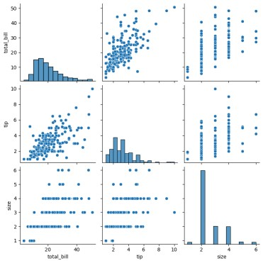

tips.time.value_counts() **count**

**time**

**Dinner** 176

**Lunch** 68

**dtype:** int64

sns.pairplot(tips,hue='time')

https://colab.research.google.com/drive/1ixdO2LyjKtMYUgtZcoc8jSInDGmeKn4_#scrollTo=J9uBGy0XX3rZ&printMode=true 4/9 10/1/24, 9:52 AM 9.9.2024-Visualization.ipynb - Colab

<seaborn.axisgrid.PairGrid at 0x79bb088f4670>

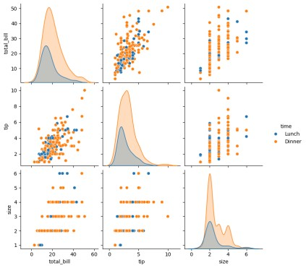

sns.pairplot(tips,hue='day')

https://colab.research.google.com/drive/1ixdO2LyjKtMYUgtZcoc8jSInDGmeKn4_#scrollTo=J9uBGy0XX3rZ&printMode=true 5/9 10/1/24, 9:52 AM 9.9.2024-Visualization.ipynb - Colab

<seaborn.axisgrid.PairGrid at 0x79bb08f1f6a0>

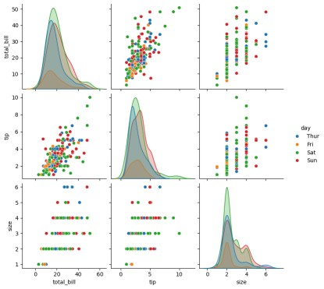

sns.heatmap(tips.corr(numeric_only=True),annot=True)

<Axes: >

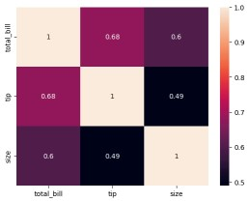

sns.boxplot(tips.total_bill)

https://colab.research.google.com/drive/1ixdO2LyjKtMYUgtZcoc8jSInDGmeKn4_#scrollTo=J9uBGy0XX3rZ&printMode=true 6/9 10/1/24, 9:52 AM 9.9.2024-Visualization.ipynb - Colab

<Axes: ylabel='total_bill'>

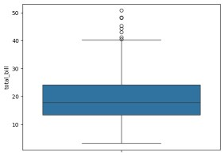

sns.boxplot(tips.tip)

<Axes: ylabel='tip'>

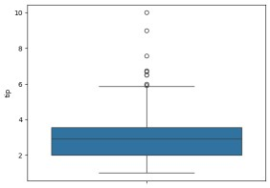

sns.countplot(tips.day)

<Axes: xlabel='count', ylabel='day'>

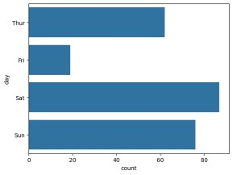

sns.countplot(tips.sex)

https://colab.research.google.com/drive/1ixdO2LyjKtMYUgtZcoc8jSInDGmeKn4_#scrollTo=J9uBGy0XX3rZ&printMode=true 7/9 10/1/24, 9:52 AM 9.9.2024-Visualization.ipynb - Colab

<Axes: xlabel='count', ylabel='sex'>

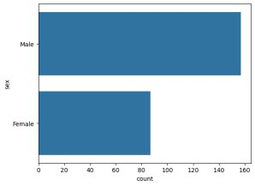

tips.sex.value_counts().plot(kind='pie')

<Axes: ylabel='count'>

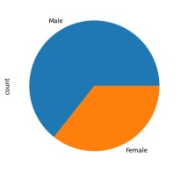

tips.sex.value_counts().plot(kind='bar')

<Axes: xlabel='sex'>

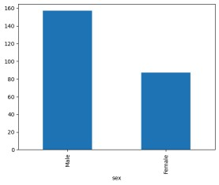

sns.countplot(tips[tips.time=='Dinner']['day'])

https://colab.research.google.com/drive/1ixdO2LyjKtMYUgtZcoc8jSInDGmeKn4_#scrollTo=J9uBGy0XX3rZ&printMode=true 8/9 10/1/24, 9:52 AM 9.9.2024-Visualization.ipynb - Colab

<Axes: xlabel='count', ylabel='day'>

https://colab.research.google.com/drive/1ixdO2LyjKtMYUgtZcoc8jSInDGmeKn4_#scrollTo=J9uBGy0XX3rZ&printMode=true 9/9

**NAME: BHUVANESHWARI K**

**ROLL NO:230701055**

**SUBJECT NAME:CS23332-FUNDAMENTALS OF DATA SCIENCE**

**DATE:08.10.2024**

In [ ]: In [19]:

In [3]: In [4]:

In [5]: **import** numpy **as** np **import** pandas **as** pd df**=**pd.read_csv('Salary_data .csv') df

df.info() <class 'pandas.core.frame.DataFram e'> RangeIndex: 30 entries,

0 to 29

Data columns (total 2 columns):

# Column Non-Null Count

Dtype --- ------------------- ----- 0 YearsExperience 30 non-null float64 1 Salary 30

non-null int64 dtypes: float64(1), int64(1) memory usage: 612.0 bytes

df.dropna(inplace**=True**) df.info()

<class 'pandas.core.frame.DataFram e'> RangeIndex: 30 entries,

0 to 29

Data columns (total 2 columns):

# Column Non-Null Count

Dtype --- ------------------- ----- 0 YearsExperience 30 non-null float64 1 Salary 30

non-null int64 dtypes: float64(1), int64(1) memory usage: 612.0 bytes

df.describe()

Out[5]: **YearsExperience Salary count** 30.000000

30.000000 **mean** 5.313333 76003.000000 **std** 2.837888

27414.429785

**min** 1.100000 37731.000000

**25%** 3.200000 56720.750000

**50%** 4.700000 65237.000000 **75%** 7.700000 100544.750000 **max** 10.500000 122391.000000 train_test_split

x_train,x_test,y_train,y_test**=**train_test_split(

In [6]: In [7]: In [20]: features,label,test_size**=**0.2,random_st

**from** sklearn.linear_model **import**

features**=**df.iloc[:,[0]].values LinearRegression label**=**df.iloc[:,[1]].values model**=**LinearRegression()

model.fit(x_train,y_train)

**from** sklearn.model_selection **import**

Out[20]:

▾ LinearRegression LinearRegression()

localhost:8888/notebooks/Regresion.ipynb# 1/2

9/16/24, 3:49 AM Regresion - Jupyter Notebook

model.score(x_trai

In [21]: n,y_train)

Out[21]: 0.9603182547438908 model.score(x_tes

t,y_test) In [23]:

Out[23]: 0.9184170849214232 model.coef

_ In [24]:

Out[24]: array([[9281.30847068]]) model.interc

ept_ In [25]:

Out[25]: array([27166.73682891]) In [26]:

In [27]: In [28]:

In [ ]: In [29]:

In [ ]:

**import** pickle

pickle.dump(model,open('SalaryPred.model','wb')

)

model**=**pickle.load(open('SalaryPred.model','rb')

)

yr_of_exp**=**float(input("Enter Years of Experience: ")) yr_of_exp_NP**=**np.array([[yr_of_exp]]) Salary**=**model.predict(yr_of_exp_NP) Enter Years of Experience: 44

print("Estimated Salary for {} years of

experience is {}: " .format(yr_of_exp,Salary) Estimated Salary for 44.0 years of experience

is [[435544.30953887]]:

localhost:8888/notebooks/Regresion.ipynb# 2/2

**NAME:BHUVANESHWARI K**

**ROLL NO:230701055**

**SUBJECT NAME:CS23332-FUNDAMENTALS OF DATA SCIENCE**

**DATE:22.10.2024**

df.info() <class

|  |  |
| --- | --- |
| In [1]: In [2]:  In [3]: **import** numpy **as** np **import** pandas **as** pd | 'pandas.core.frame.DataFr ame'> RangeIndex: 150 entries, 0 to 149 Data columns (total 5 columns):  # Column Non-Null Count  Dtype --- ------------------- ----- 0 sepal.length 150 non-null float64 1 sepal.width 150 non-null float64 2 petal.length 150 non-null float64 3 petal.width 150 non-null float64 4 variety 150 non-null object dtypes:  float64(4), object(1) memory usage: 6.0+ KB |

df.variety.value_counts()

df**=**pd.read_csv('Iris.csv' )

Out[3]: Setosa 50

Versicolor 50

Virginica 50

Name: variety, dtype: int64 df.head(

) In [4]:

# Out[4]: sepal.length sepal.width petal.length petal.width variety 0 5.1 3.5

1.4 0.2 Setosa **1** 4.9 3.0 1.4 0.2 Setosa **2** 4.7 3.2 1.3 0.2 Setosa **3** 4.6 3.1 1.5 0.2 Setosa **4** 5.0 3.6 1.4 0.2 Setosa

**from** sklearn.neighbors **import**

In [5]: In [6]: In [8]: KNeighborsClassifier

xtrain,xtest,ytrain,ytest**=**train_test_split

features**=**df.iloc[:,:**-**1].values (features,label,test_size**=**.2,rando

label**=**df.iloc[:,4].values model_KNN**=**KNeighborsClassifier(n_neighbors

**=**5) model_KNN.fit(xtrain,ytrain)

**from** sklearn.model_selection **import** train_test_split

Out[8]:

KNeighborsClassifier()

**In a Jupyter environment, please rerun this cell to show the HTML representation or trust the notebook.**

**On GitHub, the HTML representation is unable to render, please try loading this page**

**with nbviewer.org.**

localhost:8888/notebooks/KNN.ipynb 1/2

9/16/24, 3:51 AM KNN - Jupyter Notebook

est))

In [9]: In [10]:

0.9583333333333334

1.0

**from** sklearn.metrics **import** confusion_matrix

print(model_KNN.score(xtrain,yconfusion_matrix(label,model_K

train)) NN.predict(features))

print(model_KNN.score(xtest,yt

|  |  |
| --- | --- |
| Out[10]: array([[50, 0, 0],  [ 0, 47, 3],  [ 0, 2, 48]], dtype=int64) | |
| In [11]: In [ ]: | **from** sklearn.metrics **import** classification_report  print(classification_report(label,mo del_KNN.predict(features))) precision recall f1-score support  Setosa 1.00 1.00 1.00 50 Versicolor  0.96 0.94 0.95 50 Virginica 0.94  0.96 0.95 50  accuracy 0.97 150 macro avg 0.97  0.97 0.97 150 weighted avg 0.97 0.97 0.97 150 |

localhost:8888/notebooks/KNN.ipynb 2/2 **NAME: Ramya Sreevarshini B**

**ROLL NO:230701262**

**SUBJECT NAME:CS23332-FUNDAMENTALS OF DATA SCIENCE**

**DATE:29.10.2024**

**import** pandas **as** pd df**=**pd.read_csv('Social_N

In [1]: etwork_Ads.csv') df **import** numpy **as** np

|  |  |
| --- | --- |
| Out[1]: | **User ID Gender Age EstimatedSalary Purchased 0** 15624510  Male 19 19000 0 **1** 15810944 Male 35 20000 0 **2** 15668575 Female 26 43000 0 **3** 15603246 Female 27 57000 0 **4** 15804002  Male 19 76000 0 **...** ... ... ... ... ...  **395** 15691863 Female 46 41000 1 **396** 15706071 Male 51 23000  1 **397** 15654296 Female 50 20000 1 **398** 15755018 Male 36  33000 0 **399** 15594041 Female 49 36000 1  400 rows × 5 columns |
|  | df.head( |
| ) In [2]:  Out[2]: **User ID Gender Age EstimatedSalary Purchased** | |

1. 15624510 Male 19 19000 0
2. 15810944 Male 35 20000 0
3. 15668575 Female 26 43000 0
4. 15603246 Female 27 57000 0
5. 15804002 Male 19 76000 0

localhost:8888/notebooks/LogisticsRegression.ipynb 1/4 9/16/24, 3:50 AM LogisticsRegression - Jupyter Notebook

2,3]].values

In [4]: label**=**df.iloc[:,4].v

|  |  |
| --- | --- |
| Out[4]: array([[ 19, 19000],  35, 20000],  [ 26, 43000],  [ 27, 57000],  [ 19, 76000],  [ 27, 58000],  [ 27, 84000],  [ 32, 150000],  [ 25, 33000],  [ 35, 65000],  [ 26, 80000],  [ 26, 52000],  [ 20, 86000],  [ 32, 18000],  [ 18, 82000],  [ 29, 80000],  [ 47, 25000],  [ 45, 26000],  [ 46, 28000],  [ 48 29000]  label  In [5]: | [ |
| Out[5]: array([0, 0, 0, 0, 0, 0, 0, 1, 0, 0, 0, 0, 0, 0, 0, 0, 1, 1, 1, 1, 1, 1,  1, 1, 1, 1, 1, 1, 0, 0, 0, 1, 0, 0, 0, 0, 0, 0, 0, 0, 0, 0, 0, 0, 0,  0, 0, 0, 1, 0, 0, 0, 0, 0, 0, 0, 0, 0, 0, 0, 0, 0, 0, 1, 0, 0, 0, 0,  0, 0, 0, 0, 0, 0, 0, 1, 0, 0, 0, 0, 0, 0, 0, 0, 0, 1, 0, 0, 0, 0, 0,  0, 0, 0, 0, 0, 0, 1, 0, 0, 0, 0, 0, 1, 0, 0, 0, 0, 0, 0, 0, 0, 0, 0,  0, 0, 0, 0, 0, 0, 0, 0, 0, 0, 0, 0, 0, 0, 0, 0, 0, 0, 0, 0, 0, 0, 0,  1, 0, 0, 0, 0, 0, 0, 0, 0, 1, 0, 0, 0, 0, 0, 0, 0, 0, 0, 0, 0, 0, 1,  1, 0, 0, 0, 0, 0, 0, 0, 1, 0, 0, 0, 0, 0, 0, 0, 0, 0, 0, 0, 0, 0, 1,  0, 0, 0, 0, 0, 0, 0, 0, 0, 0, 0, 0, 0, 0, 0, 0, 0, 0, 0, 1, 0, 1, 0,  1, 0, 1, 0, 1, 1, 0, 0, 0, 1, 0, 0, 0, 1, 0, 1, 1, 1, 0, 0, 1, 1, 0,  1, 1, 0, 1, 1, 0, 1, 0, 0, 0, 1, 1, 0, 1, 1, 0, 1, 0, 1, 0, 1, 0, 0,  1, 1, 0, 1, 0, 0, 1, 1, 0, 1, 1, 0, 1, 1, 0, 0, 1, 0, 0, 1, 1, 1, 1,  1, 0, 1, 1, 1, 1, 0, 1, 1, 0, 1, 0, 1, 0, 1, 1, 1, 1, 0, 0, 0, 1, 1,  0, 1, 1, 1, 1, 1, 0, 0, 0, 1, 1, 0, 0, 1, 0, 1, 0, 1, 1, 0, 1, 0, 1,  1, 0, 1, 1, 0, 0, 0, 1, 1, 0, 1, 0, 0, 1, 0, 1, 0, 0, 1, 1, 0, 0, 1,  1, 0, 1, 1, 0, 0, 1, 0, 1, 0, 1, 1, 1, 0, 1, 0, 1, 1, 1, 0, 1, 1, 1,  1, 0, 1, 1, 1, 0, 1, 0, 1, 0, 0, 1, 1, 0, 1, 1, 1, 1, 1, 1, 0, 1, 1, 1, 1, 1, 1, 0, 1, 1, 1, 0, 1], dtype=int64) **import** train_test_split **from** sklearn.linear_model **import** In [6]:  LogisticRegression | |

features**=**df.iloc[:,[alues features **from** sklearn.model_selection

localhost:8888/notebooks/LogisticsRegression.ipynb 2/4 9/16/24, 3:50 AM LogisticsRegression - Jupyter Notebook

In [7]: In [8]: **for** i **in** range(1,401):

x_train,x_test,y_train,y_test**=**train_test_s

Out[8]:

LogisticRegression() plit(features,label,test_size**=**0. model**=**LogisticRegression()

model.fit(x_train,y_train) train_score**=**model.score(x_train,y_train) test_score**=**model.score(x_test,y_test) **if** test_score**>**train_score:

print("Test {} Train{} Random State {}".format(test_score,train_score,i)

Test 0.6875 Train0.63125 Random State 3

Test 0.7375 Train0.61875 Random State 4

Test 0.6625 Train0.6375 Random State 5

Test 0.65 Train0.640625 Random State 6

Test 0.675 Train0.634375 Random State 7

Test 0.675 Train0.634375 Random State 8

Test 0.65 Train0.640625 Random State 10

Test 0.6625 Train0.6375 Random State 11

Test 0.7125 Train0.625 Random State 13

Test 0.675 Train0.634375 Random State 16

Test 0.7 Train0.628125 Random State 17

Test 0.7 Train0.628125 Random State 21

Test 0.65 Train0.640625 Random State 24

Test 0.6625 Train0.6375 Random State 25

Test 0.75 Train0.615625 Random State 26

Test 0.675 Train0.634375 Random State 27

Test 0.7 Train0.628125 Random State 28

Test 0.6875 Train0.63125 Random State 29

Test 0.6875 Train0.63125 Random State 31

T t 0 6625 T i 0 6375 R d St t 37

x_train,x_test,y_train,y_test**=**train_test_s plit(features,label,test_size**=**0.2, finalModel**=**LogisticRegression() finalModel.fit(x_train,y_train)

In [9]: In [10]: **from** sklearn.metrics **import**

classification_report

print(classification_report(label,fi nalModel.predict(features)))

precision recall f1-score support

print(finalModel.score(x_train,y_tra

in)) 0 0.85 0.93 0.89 257 1 0.84 0.71

print(finalModel.score(x_test,y_test 0.77 143

))

accuracy 0.85 400 macro avg 0.85

0.834375 0.82 0.83 400 weighted avg 0.85 0.85

0.9125 0.85 400

localhost:8888/notebooks/LogisticsRegression.ipynb 3/4 9/16/24, 3:50 AM LogisticsRegression - Jupyter Notebook

In [ ]:

localhost:8888/notebooks/LogisticsRegression.ipynb 4/4

**NAME: BHUVANESHWARI K**

**ROLL NO:230701055**

**SUBJECT NAME:CS23332-FUNDAMENTALS OF DATA SCIENCE**

**DATE:05.11.2024**

In [1]:

In [2]: In [3]:

In [4]: **import** numpy **as** np **import** pandas **as** pd **import** matplotlib.pyplot plt

**import** seaborn **as** sns **%**matplotlib inline

df**=**pd.read_csv('Mall_Customer

s.csv')

df.info()

<class

'pandas.core.frame.DataFrame'

>

RangeIndex: 200 entries, 0 to

199

Data columns (total 5 columns):

# Column Non-Null Count Dtype

--- ------ ------------------ 0 CustomerID 200 non-null int64 1 Gender 200 non-null object 2 Age 200 non-null int64 3 Annual Income (k$) 200 non-null int64 4 Spending Score (1-100) 200 non-null int64 dtypes: int64(4), object(1) memory usage: 7.9+ KB **as**

df.head()

# Out[4]: CustomerID Gender Age Annual Income (k$) Spending Score (1-100)

1. 1 Male 19 15 39
2. 2 Male 21 15 81
3. 3 Female 20 16 6
4. 4 Female 23 16 77
5. 5 Female 31 17 40

localhost:8888/notebooks/K-Means Clustering.ipynb 1/8 9/16/24, 3:50 AM K-Means Clustering - Jupyter Notebook

sns.pairplot(df) In [5]:

Out[5]: <seaborn.axisgrid.PairGrid at 0x170e8e47850>

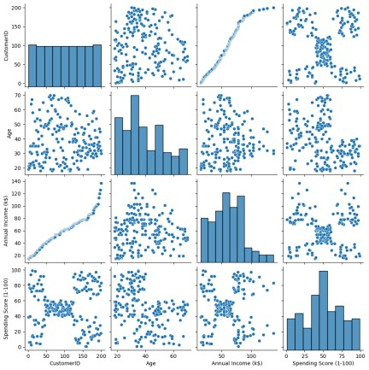

features**=**df.iloc[:,[3,4]].values In [6]:

localhost:8888/notebooks/K-Means Clustering.ipynb 2/8 9/16/24, 3:50 AM K-Means Clustering - Jupyter Notebook

**from** sklearn.cluster **import** KMeans

In [7]: model**=**KMeans(n_clusters**=**5)

model.fit(features) KMeans(n_clusters**=**5)

C:\Users\Ayyadurai\AppData\Local\anaconda

3\Lib\site-packages\sklearn\clust er\_kmeans.py:870: FutureWarning: The default value of `n_init` will chang e from 10 to 'auto' in 1.4. Set the value of `n_init` explicitly to suppre ss the warning

Out[7]:

KMeans(n_clusters=5)

warnings.warn(

C:\Users\Ayyadurai\AppData\Local\anaconda

3\Lib\site-packages\sklearn\clust er\_kmeans.py:1382: UserWarning: KMeans is known to have a memory leak on Windows with MKL, when there are less chunks than available threads. You c an avoid it by setting the environment variable OMP_NUM_THREADS=1. warnings.warn(

**In a Jupyter environment, please rerun this cell to show the HTML representation or trust the notebook.**

**On GitHub, the HTML representation is unable to render, please try loading this page with nbviewer.org.**

.loc[row_indexer,col_indexer] = value

In [8]: instead

Final**=**df.iloc[:,[3,4]]

Final['label']**=**model.predict(features) See the caveats in the documentation:

Final.head() https://pandas.pydata.org/pandas-doc

s/stable/user_guide/indexing.html#returni

C:\Users\Ayyadurai\AppData\Local\Temp\ipyng-a-view-versus-a-copy (https:// kernel_8116\470183701.py:2: Setti pandas.pydata.org/pandas-docs/stable/user ngWithCopyWarning: _guide/indexing.html#returning-a A value is trying to be set on a copy of view-versus-a-copy) a slice from a DataFrame. Try using Final['label']=model.predict(features)

# Out[8]: Annual Income (k$) Spending Score (1-100) label

1. 15 39 4
2. 15 81 2
3. 16 6 4
4. 16 77 2
5. 17 40 4

localhost:8888/notebooks/K-Means Clustering.ipynb 3/8

9/16/24, 3:50 AM K-Means Clustering - Jupyter Notebook

In [9]: sns.set_style("whitegrid") sns.FacetGrid(Final,hue**=**"label",height**=**8) \

.map(plt.scatter,"Annual Income (k$)", "Spending Score (1-100)") \

.add_legend(); plt.show()

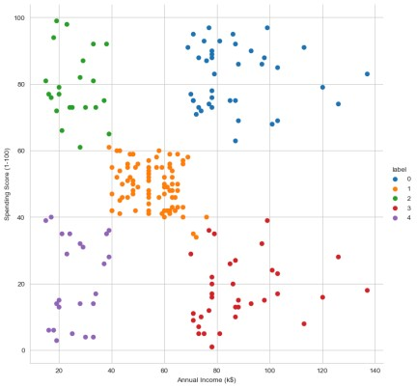

localhost:8888/notebooks/K-Means Clustering.ipynb 4/8

9/16/24, 3:50 AM K-Means Clustering - Jupyter Notebook

In [10]: features_el**=**df.iloc[:,[2,3,4]].values **from** sklearn.cluster **import** KMeans wcss**=**[]

**for** i **in** range(1,10): model**=**KMeans(n_clusters**=**i) model.fit(features_el) wcss.append(model.inertia_) plt.plot(range(1,10),wcss)

localhost:8888/notebooks/K-Means Clustering.ipynb 5/8

9/16/24, 3:50 AM K-Means Clustering - Jupyter Notebook

C:\Users\Ayyadurai\AppData\Local\anaconda3\Lib\site-packages\sklearn\clust er\_kmeans.py:870: FutureWarning: The default value of `n_init` will chang e from 10 to 'auto' in 1.4. Set the value of `n_init` explicitly to suppre ss the warning

warnings.warn(

C:\Users\Ayyadurai\AppData\Local\anaconda3\Lib\site-packages\sklearn\clust er\_kmeans.py:1382: UserWarning: KMeans is known to have a memory leak on Windows with MKL, when there are less chunks than available threads. You c an avoid it by setting the environment variable OMP_NUM_THREADS=1.

warnings.warn(

C:\Users\Ayyadurai\AppData\Local\anaconda3\Lib\site-packages\sklearn\clust er\_kmeans.py:870: FutureWarning: The default value of `n_init` will chang e from 10 to 'auto' in 1.4. Set the value of `n_init` explicitly to suppre ss the warning

warnings.warn(

C:\Users\Ayyadurai\AppData\Local\anaconda3\Lib\site-packages\sklearn\clust er\_kmeans.py:1382: UserWarning: KMeans is known to have a memory leak on Windows with MKL, when there are less chunks than available threads. You c an avoid it by setting the environment variable OMP_NUM_THREADS=1.

warnings.warn(

C:\Users\Ayyadurai\AppData\Local\anaconda3\Lib\site-packages\sklearn\clust er\_kmeans.py:870: FutureWarning: The default value of `n_init` will chang e from 10 to 'auto' in 1.4. Set the value of `n_init` explicitly to suppre ss the warning

warnings.warn(

C:\Users\Ayyadurai\AppData\Local\anaconda3\Lib\site-packages\sklearn\clust er\_kmeans.py:1382: UserWarning: KMeans is known to have a memory leak on Windows with MKL, when there are less chunks than available threads. You c an avoid it by setting the environment variable OMP_NUM_THREADS=1.

warnings.warn(

C:\Users\Ayyadurai\AppData\Local\anaconda3\Lib\site-packages\sklearn\clust er\_kmeans.py:870: FutureWarning: The default value of `n_init` will chang e from 10 to 'auto' in 1.4. Set the value of `n_init` explicitly to suppre ss the warning

warnings.warn(

C:\Users\Ayyadurai\AppData\Local\anaconda3\Lib\site-packages\sklearn\clust er\_kmeans.py:1382: UserWarning: KMeans is known to have a memory leak on Windows with MKL, when there are less chunks than available threads. You c an avoid it by setting the environment variable OMP_NUM_THREADS=1.

warnings.warn(

C:\Users\Ayyadurai\AppData\Local\anaconda3\Lib\site-packages\sklearn\clust er\_kmeans.py:870: FutureWarning: The default value of `n_init` will chang e from 10 to 'auto' in 1.4. Set the value of `n_init` explicitly to suppre ss the warning

warnings.warn(

C:\Users\Ayyadurai\AppData\Local\anaconda3\Lib\site-packages\sklearn\clust er\_kmeans.py:1382: UserWarning: KMeans is known to have a memory leak on Windows with MKL, when there are less chunks than available threads. You c an avoid it by setting the environment variable OMP_NUM_THREADS=1.

warnings.warn(

C:\Users\Ayyadurai\AppData\Local\anaconda3\Lib\site-packages\sklearn\clust er\_kmeans.py:870: FutureWarning: The default value of `n_init` will chang e from 10 to 'auto' in 1.4. Set the value of `n_init` explicitly to suppre ss the warning

warnings.warn(

C:\Users\Ayyadurai\AppData\Local\anaconda3\Lib\site-packages\sklearn\clust er\_kmeans.py:1382: UserWarning: KMeans is known to have a memory leak on Windows with MKL, when there are less chunks than available threads. You c an avoid it by setting the environment variable OMP_NUM_THREADS=1.

warnings.warn(

C:\Users\Ayyadurai\AppData\Local\anaconda3\Lib\site-packages\sklearn\clust

localhost:8888/notebooks/K-Means Clustering.ipynb 6/8 9/16/24, 3:50 AM K-Means Clustering - Jupyter Notebook

er\_kmeans.py:870: FutureWarning: The default value of `n_init` will chang e from 10 to 'auto' in 1.4. Set the value of `n_init` explicitly to suppre ss the warning

warnings.warn(

C:\Users\Ayyadurai\AppData\Local\anaconda3\Lib\site-packages\sklearn\clust er\_kmeans.py:1382: UserWarning: KMeans is known to have a memory leak on Windows with MKL, when there are less chunks than available threads. You c an avoid it by setting the environment variable OMP_NUM_THREADS=1.

warnings.warn(

C:\Users\Ayyadurai\AppData\Local\anaconda3\Lib\site-packages\sklearn\clust er\_kmeans.py:870: FutureWarning: The default value of `n_init` will chang e from 10 to 'auto' in 1.4. Set the value of `n_init` explicitly to suppre ss the warning

warnings.warn(

C:\Users\Ayyadurai\AppData\Local\anaconda3\Lib\site-packages\sklearn\clust er\_kmeans.py:1382: UserWarning: KMeans is known to have a memory leak on Windows with MKL, when there are less chunks than available threads. You c an avoid it by setting the environment variable OMP_NUM_THREADS=1.

warnings.warn(

C:\Users\Ayyadurai\AppData\Local\anaconda3\Lib\site-packages\sklearn\clust er\_kmeans.py:870: FutureWarning: The default value of `n_init` will chang e from 10 to 'auto' in 1.4. Set the value of `n_init` explicitly to suppre ss the warning

warnings.warn(

C:\Users\Ayyadurai\AppData\Local\anaconda3\Lib\site-packages\sklearn\clust er\_kmeans.py:1382: UserWarning: KMeans is known to have a memory leak on Windows with MKL, when there are less chunks than available threads. You c an avoid it by setting the environment variable OMP_NUM_THREADS=1. warnings.warn(

Out[10]: [<matplotlib.lines.Line2D at 0x170e99f3550>]

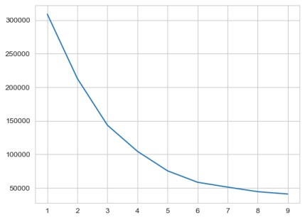

In [ ]:

localhost:8888/notebooks/K-Means Clustering.ipynb 7/8 9/16/24, 3:50 AM K-Means Clustering - Jupyter Notebook

localhost:8888/notebooks/K-Means Clustering.ipynb 8/8